STATUTORY INSTRUMENTS

S.I. No. 666 of 2006

EUROPEAN COMMUNITIES (ENERGY PERFORMANCE OF BUILDINGS)
REGULATIONS 2006

PUBLISHED BY THE STATIONERY OFFICE
DUBLIN

To be purchased directly from the
GOVERNMENT PUBLICATIONS OFFICE,
SUN ALLIANCE HOUSE, MOLESWORTH STREET, DUBLIN 2

Or by mail order from

GOVERNMENT PUBLICATIONS, POSTAL TRADE SECTION,
51 ST. STEPHEN’S GREEN, DUBLIN 2

(Tel: 01 6476834/35/36/37; Fax: 01 6476843)
Or through any bookseller

Prn. A6/2197 Price: € 3.81

S.I. No. 666 of 2006
EUROPEAN COMMUNITIES (ENERGY PERFORMANCE OF BUILDINGS)

REGULATIONS 2006

The Minister for the Environment, Heritage and Local Government, in exercise of the powers conferred on him by Section 3 of the European Communities Act 1972 (No. 27 of 1972) and for the purpose of giving effect to certain provisions of Directive 2002/91/EC of the European Parliament and of the Council of 16 December 2002 on the energy performance of buildings, hereby makes the following Regulations:

PART 1 –PRELIMINARY AND GENERAL
Citation and commencement
1. (1) These Regulations may be cited as the European Communities (Energy Performance of Buildings) Regulations 2006.
(2) These Regulations shall come into operation on 1 January 2007, save where otherwise specified in these Regulations.

Interpretation
2. (1) In these Regulations –

“accredited BER training provider” means -
(1) Sustainable Energy Ireland; or
(2) an accredited BER training provider providing a validated BER training course leading to an award recognised through the National Qualifications Authority of Ireland;

“advisory report” means a report held and which may be viewed in electronic form on the BER register, to accompany a BER certificate or provisional BER certificate, on the basis of a BER assessment of a building and in a form approved by the issuing authority with the prior approval of the Minister, which contains recommendations on how the energy performance of the building may be improved in a cost-effective manner, and which may be reproduced and issued in printed form by or on behalf of the issuing authority;

“authorised officer” may mean either an authorised officer of a building control authority or a person authorised by the issuing authority under these Regulations;

“BER” or “building energy rating” means a building energy rating recorded on the BER register on the basis of a BER assessment;

“BER assessment” means an assessment of the energy performance of a building by a BER assessor for the purpose of assigning a BER;

“BER assessor” means a person registered by the issuing authority, for a designated class or classes of building, for the purpose of BER assessment of such class or classes of building;

“BER certificate” means a certificate in a prescribed form on the basis of a BER assessment, which is held and may be viewed in electronic form on the BER register, and may be reproduced and issued in printed form by or on behalf of the issuing authority,

“BER data file” means an electronic file which contains a report on the outcome of a BER assessment of a building in a form approved by the issuing authority, which is completed by a BER assessor and provided to the issuing authority for the purpose of notifying it of the record to be made or updated on the BER register in respect of that particular building, and shall be deemed to include any calculations and related data or documents accompanying that report;

“BER record” means, as the case may be, the current and any earlier BER certificate, including any provisional BER certificate where applicable, any advisory report, any BER data file and any related data or documents, pertaining to a building;

“BER register” means a database of BER records and related data or documents established, operated, maintained and owned by the issuing authority for the purposes of these Regulations;

“BER system” means the registers, processes and rules established, operated, maintained and owned by the issuing authority for the purpose of administering BER and related activities in accordance with these Regulations;

“building control authority” has the meaning assigned to it by Section 3 of the Building Control Act 1990 (No. 3 of 1990)

“dwelling” means a building, or any part of a building, which is used or suitable for use as a dwelling

“e-mail” means electronic mail;

“fax” means a facsimile of a signed or written communication transmitted through the telecommunications system;

“issuing authority” means Sustainable Energy Ireland as established pursuant to the Sustainable Energy Act 2002 (No. 2 of 2002);

“large building” means a building with a total useful floor area in excess of 1,000m²;

“planning application” means an application for planning permission or approval pursuant to the Planning and Development Acts 2000 to 2006;

“planning notice” means a notice pursuant to the provisions of Part 8 of the Planning and Development Regulations 2001 (S.I. No. 600 of 2001);

“prescribed” means prescribed by the Minister;

“provisional BER certificate” is a certificate in a prescribed form respecting a proposed new building which is held and may be viewed in electronic form on the BER register on the basis of a BER assessment of the plans and specifications for the building prior to its construction being completed, and may be reproduced and issued by or on behalf of the issuing authority in printed form;

“public body” means-
(a) a Department of State,
(b) the Office of the President,
(c) the Office of the Attorney General,
(d) the Office of the Comptroller and Auditor General,
(e) the Office of the Houses of the Oireachtas,
(f) a local authority,
(g) the Health Service Executive,
(h) a person, body or organisation (other than the Defence Forces)
established-

(i) by or under any enactment (other than the Companies Acts), or

(ii) under the Companies Acts, in pursuance of powers conferred by or under another enactment, and financed wholly or partly, whether directly or indirectly, by means of moneys provided, or loans made or guaranteed, by a Minister of the Government or shares held by or on behalf of a Minister of the Government;

“register of BER assessors” means a database of BER assessors registered with the issuing authority and related data established, operated, maintained and owned by the issuing authority;

“substantial work has been completed” means the structure of the external walls of the building has been completed;

“the Act of 1990” means the Building Control Act 1990 (No. 3 of 1990);

“the Act of 1997” means the Dublin Docklands Development Authority Act 1997 (No. 7 of 1997);

“the Minister “ means the Minister for the Environment, Heritage and Local Government;

(2) In these Regulations –
(a) a reference to a Regulation or Schedule is to a Regulation of, or Schedule to, these Regulations, unless it is indicated that reference to some other Regulations is intended;
(b) a reference to a paragraph, subparagraph, clause or sub-clause is a reference to a paragraph, subparagraph, clause or sub-clause of the provision in which the reference occurs, unless it is indicated that reference to some other provision is intended.

Application
3. The provisions of these Regulations shall not apply to the following categories of buildings -
(a) a national monument for the purposes of the National Monuments Acts 1930 to 2004, including a recorded monument under the provisions of Section 12 of the National Monuments (Amendment ) Act 1994 or a registered historic monument under the provisions of the Section 5 of the National Monuments (Amendment) Act 1987; or
(b) a protected structure or proposed protected structure within the meaning of the Planning and Development Acts 2000 to 2006; or
(c) a building used as a place of worship or for the religious activities of any religion; or
(d) a temporary building as defined in Classes 10 to 13 of the Third Schedule to the Building Regulations 1997 (S.I. No 497 of 1997); or
(e) an industrial building not intended for human occupancy over extended periods and where the installed heating capacity does not exceed 10 W/m²; or
(f) a non-residential agricultural building where the installed heating capacity does not exceed 10 W/m²; or
(g) a stand alone building with a total useful floor area of less than 50m².

PART 2- ALTERNATIVE ENERGY SYSTEMS
4. This Part of the Regulations shall apply to the design of any large building for which a planning application is made, or a planning notice is published, on or after 1 January 2007.

5. (1) A person who commissions the construction of a large new building shall ensure, before work commences on its construction, that due consideration has been given to the technical, environmental and economic feasibility of installing alternative energy systems in the proposed large building, and that the use of such systems has been taken into account, as far as practicable, in the design of that building.
(2) The alternative energy systems to be considered for the purposes of paragraph (1) shall include-
(a) decentralised energy supply systems based on renewable energy,
(b) combined heat and power systems,
(c) district or block heating or cooling, if available,
(d) heat pumps.

(3) Compliance with the requirement specified in paragraph (1) shall be demonstrated either by reference to-

(a) a study published by the issuing authority which assesses the appropriateness or otherwise of the alternative energy systems which may be technically, environmentally and economically feasible for large buildings or particular types of large building, or

(b) a particular feasibility study carried out for the proposed large
building.

(4) A study under subparagraph (3) (a) may be constituted by the employment of information technology approved by the issuing authority for that purpose and the provision of the results therefrom.

(5) A feasibility study under subparagraph (3) (b) shall be carried out by a suitably qualified person (who may employ appropriate information technology for that purpose) and shall include specific recommendations in relation to the utilisation of alternative energy systems, including those specified in this Regulation, to serve the large building in question.
(6) The results of the consideration of the feasibility of alternative energy systems required under this Regulation shall be incorporated in a report on the design of the relevant large building and shall be retained by the person who commissioned that building for a period of 5 years from the date of completion of the building and shall be produced, on demand, to the building control authority within whose functional area the large building is located.

6. (1) Failure to comply with the provisions of this Part of these Regulations is an offence.
(2) Proceedings for an offence under this Part may be brought and prosecuted by the building control authority within whose functional area the large building is located.

PART 3- BUILDING ENERGY RATING
7. (1) A person who commissions the construction of a building of a class referred to in subparagraph (a) or (b) of paragraph (4) construction of which commences on or after such date specified for that class in the said subparagraphs shall, before such building is occupied for the first time, secure a BER certificate (in the form prescribed by the First Schedule or Second Schedule to these Regulations, as appropriate) and advisory report in relation to the building and shall produce a printed copy of such BER certificate and advisory report to the building control authority in whose functional area the building is situated, on demand being made by that authority for its production.

(2) A person who offers for sale or letting (whether in writing or otherwise)—
(a) a building of a class referred to in subparagraph (a) or (b) of paragraph (4) construction of which commences on or after such date specified for that class in the said subparagraphs, hereinafter referred to as a ‘new building’, or
(b) on or after 1 January 2009, a building that is in existence on or before 1 January 2009,
and any agent acting on behalf of such person in connection with such offering, shall produce a printed copy of the BER certificate and advisory report in relation to the building to any person expressing an interest in purchasing or taking a letting of the building and, on demand, to the building control authority in whose functional area the building is situated.

(3) Where a new building is constructed, the following applies for the purposes of subparagraph (2) (a):
(i) where the building is being offered for sale or letting (whether in writing or otherwise) on the basis of the plans and specifications for its proposed construction, a printed copy of the provisional BER certificate in the form prescribed in the Second Schedule to these Regulations based on these plans and specifications in relation to the proposed building, and related advisory report, shall be produced to any of the persons referred to in paragraph (2);
(ii) on the completion of construction of the building referred to in subparagraph (i) a printed copy of the BER certificate in the form prescribed in the First Schedule to these Regulations and of the related advisory report in relation to the completed building, which take account of any changes implemented during its construction relative to the plans, specifications or other data on which the provisional BER was based, shall be produced to any purchaser or tenant, before completion of such sale or letting and, on demand, to the building control authority in whose functional area the building is situated.

(4) Subject to paragraph (5), a BER certificate is required for the following classes of buildings with effect from the dates specified hereunder for each class –

(a) new dwellings commencing on or after 1 January 2007;

(b) new buildings, other than dwellings, commencing on or after
1 July 2008;

(c) buildings of any class in existence at 1 January 2009 offered
for sale or letting on or after 1 January 2009.

(5) The provisions of subparagraphs (a) and (b) of paragraph (4) shall not apply to the following buildings –

(a) a new dwelling for which planning permission was applied for or a planning notice was published on or before 31 December 2006 , and where substantial work is completed by 30 June 2008;

(b) a new building, other than a dwelling, for which planning permission is applied for or a planning notice is published on or before 30 June 2008 and where substantial work is completed by 30 June 2010, except when such building is offered for a second or subsequent sale or letting.

(c) a new dwelling in respect of which an application for certification for the purposes of Section 25 of the Act of 1997 was made on or before 31 December 2006 and where substantial work is completed by 30 June 2008;

(d) a new building, other than a dwelling, in respect of which an application for certification under Section 25 of the Act of 1997 was made on or before 30 June 2008 and where substantial works is completed by 30 June 2010 except where such building is offered for a second or subsequent sale or letting;

(e) any building, other than a dwelling, which is exempted development by virtue of Section 25(7)(a)(i) of the Act of 1997 and where substantial work on such development is completed by 30 June 2010 except where such building is offered for a second or subsequent sale or letting.

(6) A person required to produce a BER certificate and related advisory report for a building under this Regulation shall warrant that such BER certificate and advisory report as he or she produces corresponds to the current BER record for the building on the BER register.

Public Service Buildings
8. A public body shall, in relation to a large building occupied by it on or after 1 January 2009, secure and display a BER certificate in a prescribed form and display such BER certificate in a prominent place clearly visible to the public.

Production of BER certificate
9. (1) A building control authority or an authorised officer thereof may demand, from the owner of a building, or the agent of such owner, within the functional area of the authority, the production of a printed copy of the BER certificate required in respect of the building by these Regulations, and if the building owner or the agent of such owner as the case may be refuses or fails to produce without reasonable excuse the printed copy of the BER certificate then and there, he or she, unless within 28 days after the day on which production was demanded he or she produces a printed copy of the BER certificate to the authority, commits an offence.

(2) Where a person produces a printed copy of the BER certificate to an authorised officer of the building control authority but refuses or fails to permit the said officer to read and examine it, that person commits an offence and the authorised officer may demand of the person his or her name and address.

10. (1) A person who contravenes any of the requirements of this Part of these Regulations commits an offence.
(2) Proceedings for such an offence may be brought and prosecuted by the building control authority within whose functional area is situated the building in relation to which an alleged breach of this Part of these Regulations has occurred.

Part 4- ADMINISTRATION OF BER SYSTEM
Registration of BER assessors
11. (1) Subject to paragraphs (3) and (4), the issuing authority may register BER assessors to assess the energy performance of buildings in accordance with these Regulations.

(2) In registering a BER assessor, the issuing authority shall designate the class or classes of buildings in respect of which the BER assessor is authorised to carry out BER assessments.

(3) The issuing authority shall not consider a person for registration as a BER assessor unless –

(a) the person makes application for registration to the issuing authority in the form specified by the issuing authority for such purpose;

(b) the application for registration is accompanied by any fee specified by the issuing authority; and

(c) the person meets any other requirements specified by the issuing authority.

(4) In considering an application for registration as a BER assessor, the issuing authority must be satisfied that the applicant has successfully completed a validated training course provided by an accredited BER training provider in relation to BER assessment for the relevant designated class or classes of buildings.

(5) A BER assessor who is registered by the issuing authority in respect of one class of building may apply to the said authority to be registered in respect of another class or classes of building, and may be so registered, subject to compliance with the provisions set out in paragraphs (3) and (4) and payment of any fee specified by the issuing authority.

(6) A BER assessor shall be required to renew his or her registration at such frequency as may be determined by the issuing authority, subject to the payment of any registration renewal fee specified by the said authority.

(7) The issuing authority shall provide each BER assessor with a certificate of registration for the designated class or classes of buildings to which his or her registration pertains and the certificate, if requested by the owner of a building or the owner’s agent, shall be presented for inspection to the owner or the owner’s agent as the case may be.

(8) Where the issuing authority suspends or terminates the registration of a person as a BER assessor, it shall note, in the register at the entry for that person as a BER assessor, the suspension or termination of the appointment and the date on which it was suspended or revoked.

(9) The issuing authority may, having regard to all the circumstances of the case, suspend or terminate the registration of a BER assessor following-
-
(a) failure by the BER assessor to attend a course of periodic training if required by the issuing authority or to satisfactorily complete such a training course, or

(b) failure by a BER assessor to comply with a direction under these Regulations, or

(c) failure by the BER assessor to carry out a building energy performance assessment for BER purposes in a fit and proper manner, or to maintain or provide satisfactory data, documentation or records of any such assessment, or

(d) the committing, or aiding or abetting the committing, by the BER assessor, of an offence under these Regulations, or

(e) the forming of an opinion by the issuing authority that the BER assessor has ceased to be capable of performing his or her functions under these Regulations properly and efficiently.

(10) A suspension or termination of registration under paragraph (9) shall be notified to the person concerned in writing and shall state the reasons for the suspension or termination and inform the person of the appeal procedure under paragraph (11).

(11) A person whose registration has been suspended or terminated under paragraph (10) may, within 14 days of the said suspension or termination, appeal against the suspension or termination to the judge of the District Court within whose district the person principally carries out BER assessments. The Court may confirm or withdraw the suspension or termination and the issuing authority shall annotate the register maintained by it accordingly.

(12) A person whose registration as a BER assessor has lapsed or been suspended or terminated may be directed by the issuing authority to return to the issuing authority or to destroy any data or documentation provided by building owners or their agents, and any copies thereof, in relation to BER assessments carried out by him or her in his or her capacity as a BER assessor.

(13) A person whose registration as a BER assessor has lapsed, been suspended or terminated and who represents himself or herself as a BER assessor commits an offence.

(14) A person who, not being such, purports to be a BER assessor for a designated class or classes of buildings or an authorised officer under these Regulations commits an offence.

(15) A person who purporting to give information to a BER assessor, an issuing authority or an authorised officer for the performance of his or her functions under these Regulations-

(a) makes a statement that he or she knows to be false or misleading in a material particular or recklessly makes a statement which is false in a material particular, or

(b) fails to disclose a material particular

commits an offence.

Directions by Issuing Authority
12. (1) The issuing authority may from time to time issue directions to BER assessors in relation to –

(a) the manner in which the BER assessments are to be carried out;

(b) the manner in which BER certificates, including provisional BER certificates, and accompanying advisory reports are to be issued;

(c) the qualifications and training requirements for BER assessors;

(d) the records, data bases and documentation to be maintained by BER assessors;

(e) data and documentation to be provided by BER assessors to the issuing authority and the format of such data and documentation;

(f) codes of practice to be respected by BER assessors, and

(g) such other matters as are reasonably necessary for the proper
administration of the BER system.

(2) A BER assessor shall comply with any direction given under paragraph (1) of this Regulation.

Application for BER assessment
13. An application for a BER assessment in respect of a building, in the form specified by the issuing authority, shall be made by the owner of the building, or the owner’s agent, to a BER assessor either in person, by post, by fax, by telephone, or by e-mail.

Levy
14. (1) The registered BER assessor shall pay to the issuing authority a levy determined by the issuing authority in respect of each BER assessment carried out on a building and submitted as a BER data file by the said assessor to the issuing authority for the purposes of issuing a BER certificate, or provisional BER certificate, and related advisory report.
(2) The revenue from the levy specified in paragraph (1) shall be solely used, by the issuing authority, to defray costs incurred by the issuing authority in establishing, operating, and maintaining the BER system including publicising the said system.

BER assessment of a building
15. (1) The assessment of the energy performance of a building under these Regulations shall be carried out by a BER assessor.
(2) The BER assessment of a building shall be carried out using procedures, including calculation method and software, approved by the issuing authority and including a survey of the building where required by direction of the issuing authority.
(3) In carrying out a BER assessment of a building, a BER assessor shall comply with any direction given by the issuing authority in relation to the manner in which the assessment is to be carried out.
(4) A BER assessor may refuse to carry a BER assessment of a building if in his or her opinion any part of the building or any of its equipment is in such a condition that it would not be safe or practicable to carry out that assessment.
(5) Where a BER assessor refuses to carry out a BER assessment of a building in accordance with paragraph (4), he or she shall return to the owner of the building or the owner’s agent, as the case may be, any fee paid under these Regulations in respect of the application for that assessment.

BER data files, certificates and advisory reports
16. (1) The form of BER data files and associated data or documents shall be determined by the issuing authority.
(2) A BER assessor upon completion of a BER assessment shall submit to the issuing authority the related BER data file completed by him or her and associated data and/or documents as specified by the issuing authority.

(3) A BER certificate, or provisional BER certificate where applicable, and related advisory report for a building shall not be issued by the BER assessor to the building owner or the owner’s agent, as the case may be, unless and until the BER data file is accepted into the BER register maintained by the issuing authority.

(4) Subject to paragraph (5), a BER certificate and related advisory report for a building shall be valid until the expiration of 10 years from the date of its issue.
(5) A BER certificate and related advisory report shall be rendered invalid if there is any material change in the building to which it relates which could affect its energy performance, including-
(a) any significant deterioration in the fabric of the building; or
(b) any extension of the building; or
(c) any change in the heating system for the building or in the
type of fuel used by that system.
.
(6) A provisional BER certificate, where applicable, shall be valid for a period not exceeding 24 months from the date of its issue.

(7) Upon the issue of a BER certificate or provisional BER certificate and related advisory report for a building within the period of validity of the existing BER certificate or provisional BER certificate and related advisory report, the existing BER certificate or provisional BER certificate and related advisory report shall be deemed to stand revoked.

Cancellation of BER data file or BER certificate
17. (1) The issuing authority may revoke a BER data file for a building compiled by a BER assessor where it has reasonable grounds for believing that the BER data file was not completed or issued in accordance with these Regulations, and shall enter that revocation into the BER record for that building.

(2) Where a BER data file is revoked, any BER certificate (and related advisory report), including a provisional BER certificate (and related advisory report) where applicable, issued on foot of that data file shall be deemed to stand revoked, and that revocation shall be entered by the issuing authority into the BER record for that building.

(3) Where the issuing authority revokes a BER data file or BER certificate, the issuing authority may demand, in writing, the giving up by the owner of the building or by the owner’s agent, to the issuing authority any extant written version or copy of the relevant BER certificate and related advisory report, within 14 days of the making of such demand.

(4) A person who fails to comply with a demand under paragraph (3) commits an offence.

(5) Where a BER data file or BER certificate is revoked under this Regulation –
(a) an application may be made by the person who paid a fee for the relevant BER assessment to the BER assessor who carried out the BER assessment for reimbursement of that fee, and
(b) the BER assessor shall make the reimbursement referred to in subparagraph (a) if he or she is satisfied that the fee for the BER assessment in respect of which the BER data file relates was paid by the person making the application.

(6) Where the issuing authority revokes a BER data file or BER certificate under these Regulations, it shall immediately inform the BER assessor who issued the BER data file of the date the BER report or BER certificate was revoked, the reason for the revocation and the address or other identifier of the building to which the revoked BER report or revoked BER certificate relates.

Alteration, defacement etc of BER certificate and related advisory report
18. (1) No person other than the issuing authority shall, either by writing, drawing or in any other manner alter, deface, mutilate or add anything to a printed copy of a BER certificate or the related advisory report or any entry made therein,
(2) No person shall produce-
(a) a printed copy of any BER certificate or advisory report for any building which has been altered, defaced, mutilated or added to contrary to paragraph (1), or upon which the figures have become illegible or the colour has become altered by fading or otherwise; or
(b) a BER certificate or advisory report save in relation to the building for which it was issued; or
(c) a BER certificate or advisory report which has become void or the validity of which has expired; or
(d) any colourable or other imitation of a BER certificate or advisory report.

(3) The issuing authority may require the owner of a building or, as the case may be, through his or her agent, to surrender to it for correction a BER certificate or advisory report where the authority has reason to believe that the BER certificate or advisory report contains particulars which are not correct and, upon being so required, the owner of the building or, as the case may be, the owner’s agent, shall surrender the relevant documents to the issuing authority forthwith which shall have issued to the owner or, as the case may be, the owner’s agent, a replacement BER certificate or advisory report.

(4) Any person who contravenes this Regulation commits an offence.

Records, data and documentation
19. (1) All data, documentation and records kept by a BER assessor in connection with the carrying out of BER assessments under these Regulations are the property of the issuing authority which has the power to demand from the BER assessor any such data, documentation or records as it considers appropriate.

(2) BER certificates, provisional BER certificates and related advisory reports issued under these Regulations shall be deemed to be and shall remain the property of the issuing authority and shall be furnished to the authority on demand for such amendment, cancellation or reissue as the circumstances may warrant.

(3) The lawful BER record in relation to a building shall be that maintained on the BER register by the issuing authority.

(4) The most recent BER record entered in relation to a building on the BER register by the issuing authority shall be deemed to supercede any previous BER record for that building.

Registers by issuing authority
20. (1) The issuing authority shall establish, operate and maintain –

(a) a register of BER assessors registered by the issuing authority;

(b) a BER register comprising BER certificates, provisional BER certificates, advisory reports, BER data files and related data or documents;

(c) any other register that the issuing authority considers necessary for the proper administration of the BER system.

(2) Any register established under paragraph (1) may be held in non-
legible form provided it is capable of being reproduced in legible form.

(3) Each register established under paragraph (1) shall be a public record, and shall be kept under the management of the issuing authority.

(4) In relation to the registers established under paragraph (1), the following access rights shall apply-

(a) Extracts from the register of BER assessors, comprising the name of each current BER assessor, his or her employer (if any) and place of business, contact details, and the designated classes of buildings to which his or her BER registration applies, shall be open to public inspection on the internet or, during normal office hours, at the offices of the issuing authority;

(b) Extracts from the BER register, comprising BER certificates, provisional BER certificates where applicable and advisory reports, shall be open to public inspection on the internet or, during normal office hours, at the offices of the issuing authority;

(c) Other than provided for in subparagraphs (a) and (b), a data file or other extract from a register relating to a BER assessment for a particular building shall normally only be made available to-
(i) the BER assessor that carried out the relevant BER
assessment, or his or her then employer; or

(ii) a BER assessor undertaking any subsequent BER
assessment of the relevant building, or his or her
employer; or

(iii) the relevant building owner, or the agent of that building
owner, via a BER assessor.

(d) Subject to compliance with the provisions of the Data Protection Act 1987, the issuing authority may allow publication or access, on a restricted or an open basis, to any extract from any register maintained by the authority under these Regulations where the authority is satisfied that such publication or access is in the public interest.

Evidential Value
21. (1) In any proceedings a certificate signed by an authorised officer of the issuing authority containing only information stated in that certificate to be taken from a register maintained by the issuing authority shall be sufficient evidence of the facts stated therein until the contrary is shown.

(2) In any proceedings a document purporting to be a certificate under paragraph (1) shall be deemed to be such a certificate and to have been signed by an authorised officer of the issuing authority, until the contrary is shown.

(3) A certificate under paragraphs (1) or (2) that purports to bear a facsimile signature of the authorised officer of the issuing authority concerned or a copy of such signature applied by means of a stamp or produced by a computer shall be deemed for the purpose of this article have been signed by an authorised officer, until the contrary is shown.

PART 5- ENFORCEMENT
Appointment and powers of authorised officers
22. (1) The issuing authority may appoint persons to be authorised officers for the purposes of enforcing these Regulations.
(2) An authorised officer –
(a) shall be furnished with a warrant of his or her appointment, and
(b) when exercising a power conferred on him or her under this Regulation shall, if requested by any person affected, produce the warrant of his or her appointment.

Power of authorised officers to enter, inspect etc. buildings
23. (1) An authorised officer may enter, inspect and examine a building or any part of a building for the purpose of forming an opinion as to whether or not a BER data file or BER certificate issued for the building, or part of the building, is warranted.

(2) An authorised officer may do all such things and make all such requirements in relation to the building as are reasonably necessary for the purpose of carrying out an inspection under paragraph (1).

(3) A person who -
(a) fails to permit an inspection of a building under this Regulation;

(b) without reasonable excuse fails or refuses to comply with any request or requirement made by an authorised officer under this Regulation,

(c) obstructs, impedes, interferes with or assaults an authorised officer in the exercise of a power under this Regulation,

(d) gives to an authorised officer information which is false or misleading in a material respect, or

(e) alters, suppresses, or destroys any BER data file, related calculations, BER certificate (including provisional BER certificate), advisory report, book, document or record, including a printed copy thereof, and including electronic data, which the person concerned has been requested or required to produce, or may reasonably expect to be required to produce,

commits an offence.

Prosecution
24. (1) Proceedings for an offence under of these Regulations may be brought and
prosecuted by the building control authority or the issuing authority as appropriate.
(2) Where an offence under these Regulations is committed by a body corporate, or by an unincorporated body of persons, or by a person purporting to act on behalf of a body corporate or on behalf of an unincorporated body of persons, and it is proved to have been committed with the consent or connivance of or to be attributable to any neglect on the part of any person who when the offence was committed, was, or purported to act as, a director, manager, secretary or other officer or member of such body, such other person as well as the body, or the person purporting to act on behalf of the body, commits an offence and is liable to be proceeded against and punished as if he or she were guilty of the first mentioned offence.

Penalties
25. A person guilty of an offence under -
(1) Regulations 6(1), 9(1), 9(2), 10(1), 11(13), 11(14), 11(15), 17 (4) and 18(4) of these Regulations is liable on summary conviction to a fine not exceeding €5,000;
(2) Regulation 23 (3) of these Regulations is liable on summary conviction to a fine not exceeding €5,000, or a to term of imprisonment not exceeding 3 months, or to both fine and imprisonment

FIRST SCHEDULE Article 7
Form of Building Energy Rating (BER) for New Dwelling
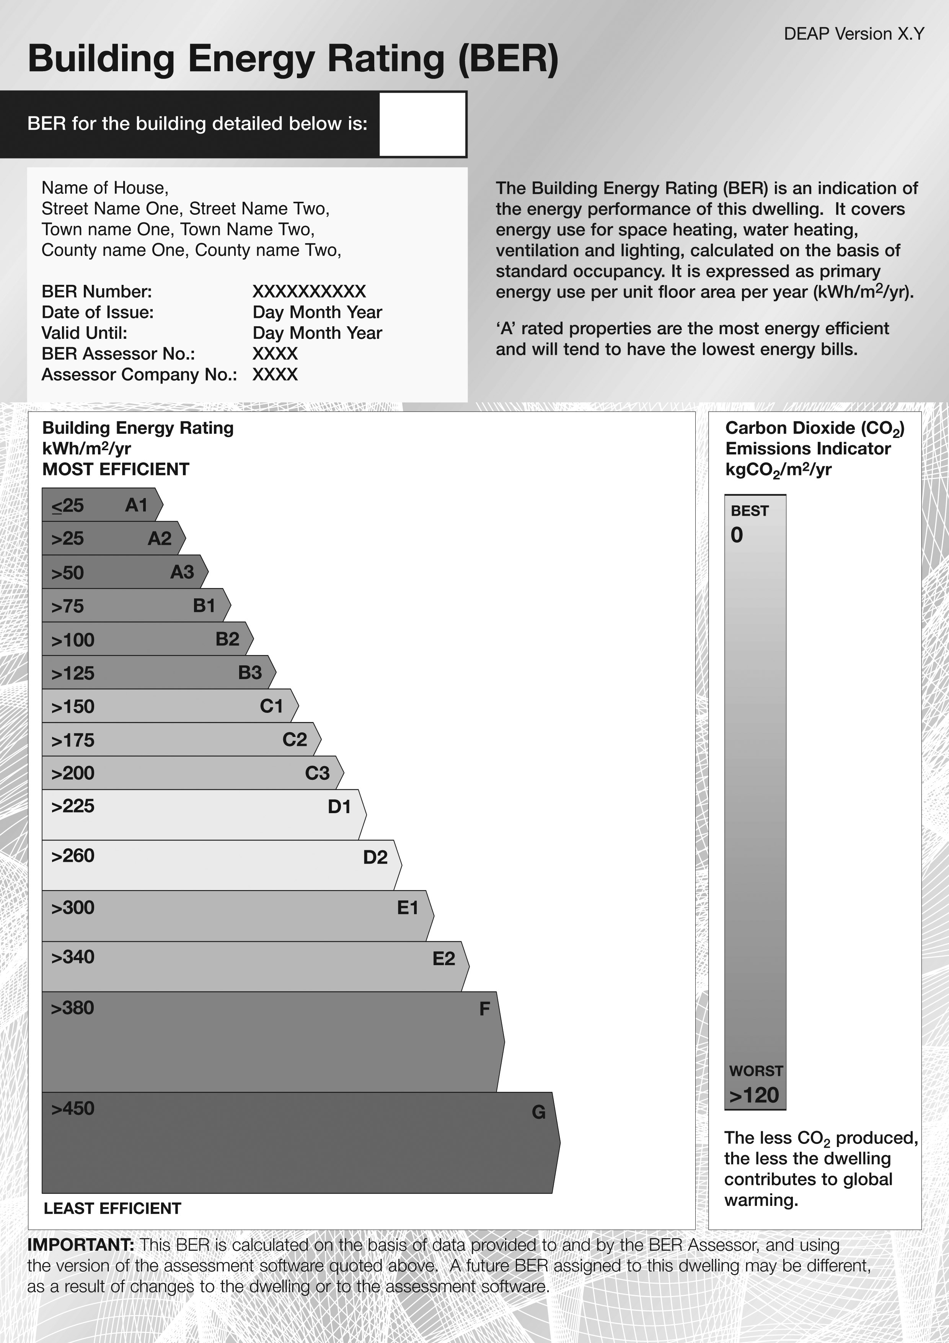

SECOND SCHEDULE Article 7
Form of Provisional Building Energy Rating (BER) for New Dwelling
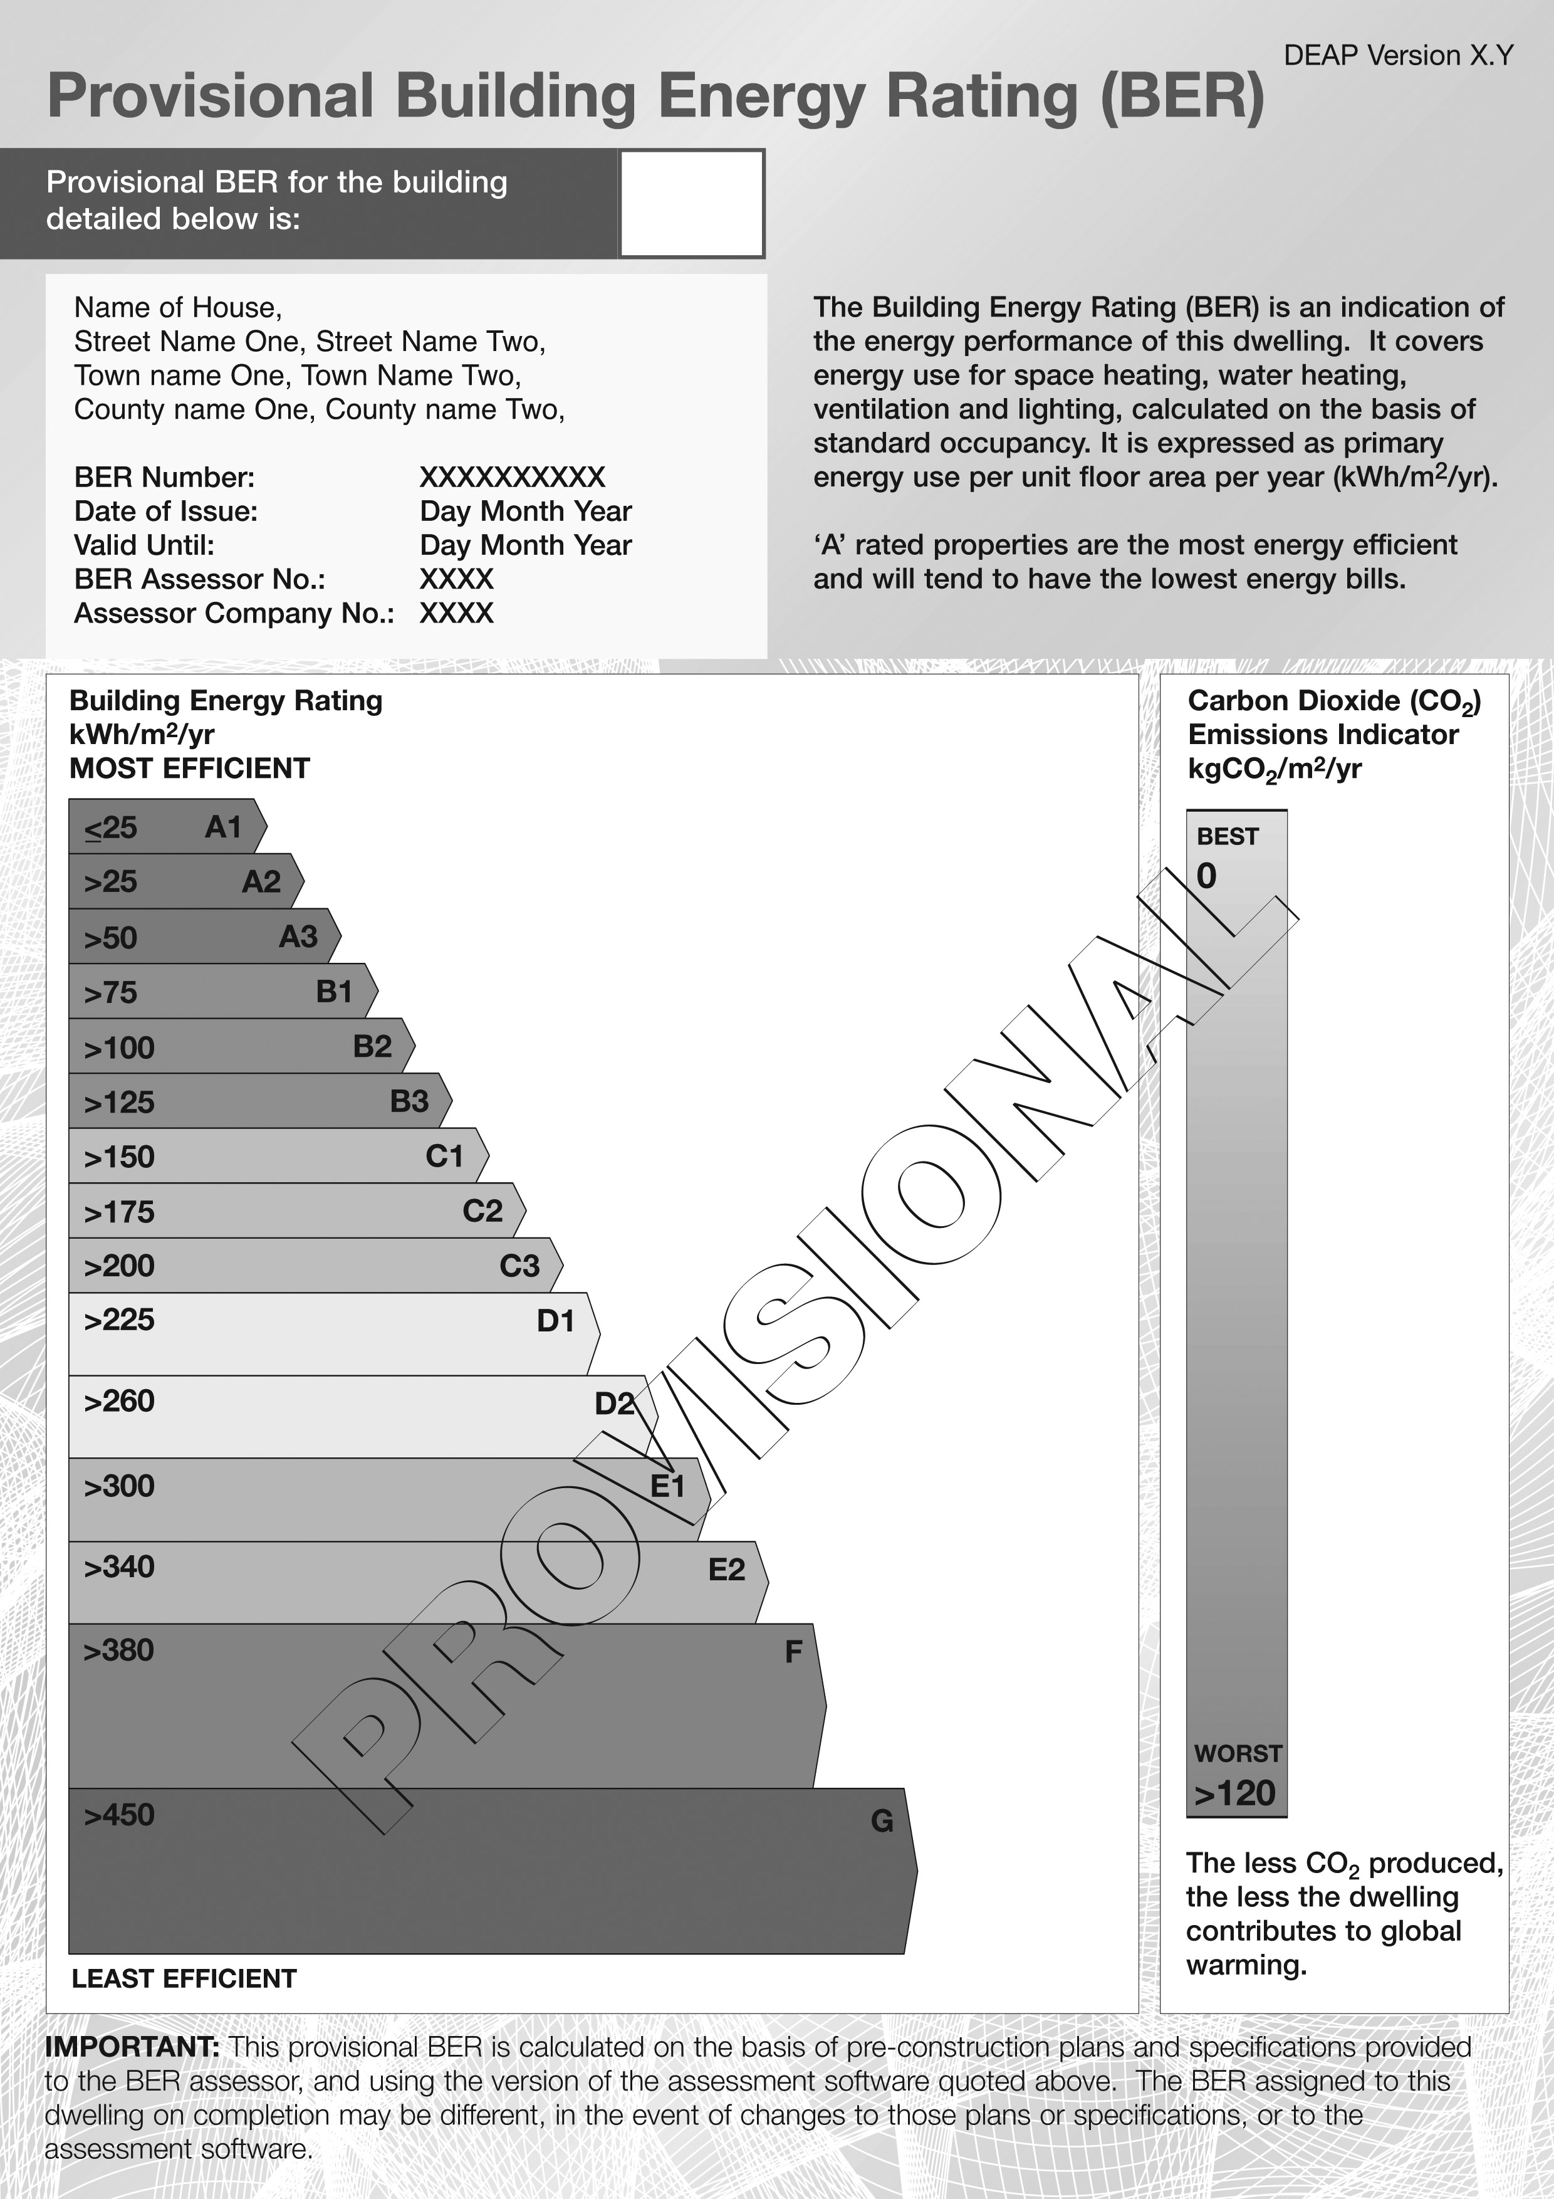

Given under the Official Seal of the Minister for
the Environment, Heritage and Local
Government
this 19th day of December 2006.
L.S.

___Dick Roche_______________
Minister for the Environment, Heritage
and Local Government.

EXPLANATORY NOTE

(This note is not part of the Instrument and does not purport to be a legal interpretation).

These Regulations provide for the legal transposition and implementation of articles 5 and 7 of the EU Energy Performance of Buildings Directive (2002/91/EC of 16 December 2002).

The Regulations require the designers of large buildings (total useful floor area of more than
1000 m²) to consider, during the design stage, the economic, environmental and technical
feasibility of installing alternative/renewable energy systems- including combined heat and
power (CHP), district or block heating if available and heat pumps. This requirement will
apply to large buildings for which planning permission is applied for on or after 1 January
2007.

The Regulations also require the Building Energy Rating (BER) of buildings as follows:
- new Dwellings commencing on or after 1 January 2007;
- new Non-Domestic Buildings commencing on or after 1 July 2008; and
- existing buildings, when let or sold, on or after 1 January 2009.

The operative dates for BER cited above will not apply to:
- new Dwellings for which planning permission is applied for on or before 31 December 2006 and which are substantially completed by 30 June 2008; and
- new Non- Domestic buildings for which planning permission is applied for on or before 30 June 2008 and which are substantially completed by 30 June 2010.

A limited number of building categories are exempt from the Regulations, as envisaged in the relevant EU Directive e.g. protected structures, places of worship.

OJ No. L 1/65, 4 January 2003

